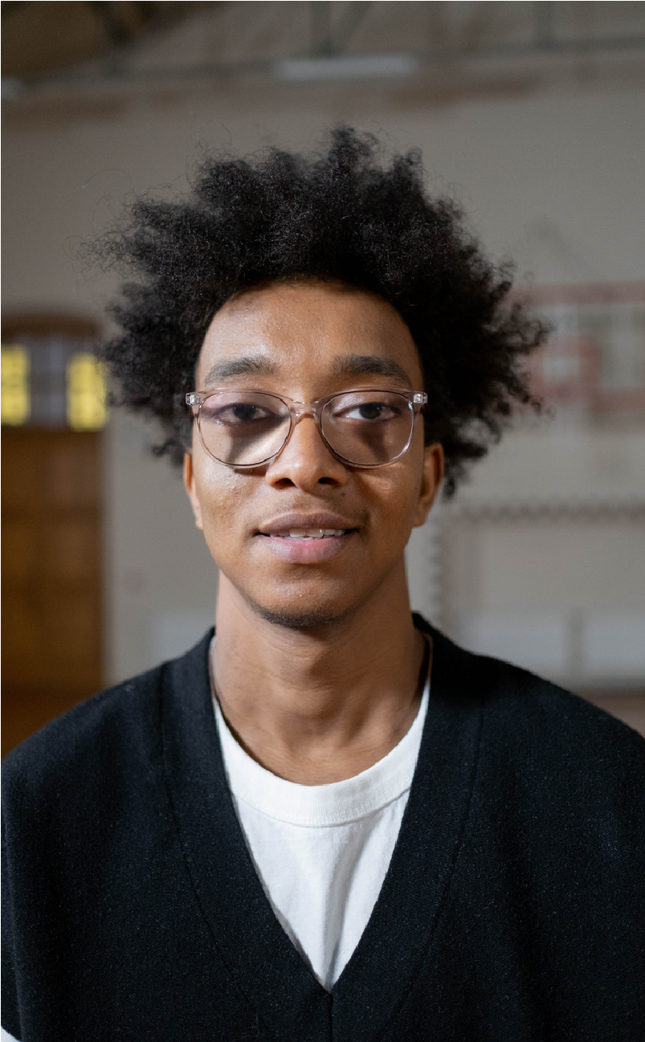

Shah

Dhairya

CREATIVE DESIGNER

I am a professional creative designer

with 1 years of experience project

management, advertisement, and

computer aided design. Proven ability to

transform client ideas into beautiful,

functional design solutions.

EDUCATION

Get 82.76%

Diploma in Computer Eng.

10th Pass at D.N.High School, Anand

B & B Institute of Technology

WORK EXPERIENCE

Creative Designer

Senior Designer

15 Days Internship from Charotar Gas Sahakari Mandali Limited, Anand

CONTACT

SKILLS

+01 7069276763

Dhairya_stu@bbit.ac.in

Shahdhairya.blogspot.com

HTML

C++

CSS

C